

SRS - Software Requirement Specification
AI Interview Platform
Version: 1.0

– Hanoi, May 2026 –

Table of Contents
Table of Contents ii
Revision History ii
1. Introduction 1
1.1 Purpose 1
1.2 Document Conventions 1
1.3 Intended Audience and Reading Suggestions 1
1.4 Product Scope 1
1.5 References 1
2. Overall Description 2
2.1 Product Perspective 2
2.2 Product Functions 2
2.3 User Classes and Characteristics 2
2.4 Operating Environment 2
2.5 Design and Implementation Constraints 2
2.6 User Documentation 2
2.7 Assumptions and Dependencies 3
3. External Interface Requirements 3
3.1 User Interfaces 3
3.2 Hardware Interfaces 3
3.3 Software Interfaces 3
3.4 Communications Interfaces 3
4. System Features 4
4.1 System Feature 1 4
4.2 System Feature 2 (and so on) 4
5. Other Nonfunctional Requirements 4
5.1 Performance Requirements 4
5.2 Safety Requirements 5
5.3 Security Requirements 5
5.4 Software Quality Attributes 5
5.5 Business Rules 5
6. Other Requirements 5
Appendix A: Glossary 5
Appendix B: Analysis Models 5
Appendix C: To Be Determined List 6

Revision History
Name | Date | Reason For Changes | Version
SRS 1.0 | 05/2026 | Create new Software Requirement Specification | 1.0

Introduction

Purpose
This Software Requirements Specification (SRS) document defines the software requirements for the AI Interview Platform, Version 1.0. The purpose of this document is to describe the functional and non-functional requirements that the system must satisfy in order to support the development, testing, deployment, and maintenance of the product.
The AI Interview Platform is an AI-powered interview preparation system designed to help users improve their interview readiness through personalized practice, intelligent feedback, and measurable progress tracking. The system enables users to upload resumes or CVs, define target job positions, provide job descriptions, analyze skill gaps, participate in AI-generated mock interviews, receive AI-based feedback, follow personalized learning roadmaps, and monitor their improvement through progress dashboards.
This SRS covers the software requirements for Phase 1 of the AI Interview Platform. The scope of this release focuses on the core web-based interview preparation features, including user account management, resume/CV management, target job configuration, skill gap analysis, AI mock interview practice, answer evaluation, feedback generation, personalized roadmap creation, progress tracking, notification support, and basic administrative management.
This document does not cover advanced features planned for future releases, such as real-time voice interview processing, native mobile applications, multi-language interview support, payment integration, mentor marketplace features, or enterprise recruitment integrations. These features may be specified in future versions of the SRS if they are approved for later development phases.
The intended use of this document is to provide a clear and shared understanding of what the system shall do and how it shall behave. It serves as a reference for business analysts, product owners, developers, testers, UI/UX designers, project managers, and other stakeholders involved in the project.

Document Conventions
This SRS follows a structured requirement specification format to ensure that all requirements are clear, consistent, traceable, and testable. The following conventions are used throughout this document.

Requirement Identification
Each requirement is assigned a unique identifier to support requirement tracking, development planning, testing, and change management.
Requirement Type | Identifier Format | Example
Functional Requirement | FR-XXX | FR-001
Non-functional Requirement | NFR-XXX | NFR-001
Business Rule | BR-XXX | BR-001
Data Requirement | DR-XXX | DR-001
Interface Requirement | IR-XXX | IR-001
Use Case | UC-XXX | UC-001
Assumption | ASM-XXX | ASM-001
Constraint | CON-XXX | CON-001
Each requirement identifier must be unique and must not be reused, even if a requirement is removed or changed in later versions of the document.

Requirement Priority
Each requirement is assigned an individual priority level. Priorities from higher-level features are not automatically inherited by detailed requirements. Every requirement statement shall have its own priority classification.
Priority | Meaning
High | The requirement is essential for Phase 1 and must be implemented for the system to be considered acceptable.
Medium | The requirement provides important value but may be deferred if time or resources are limited.
Low | The requirement is optional for Phase 1 and may be considered for future releases.

Requirement Language
The following requirement keywords are used in this document:
Keyword | Meaning
Shall | Indicates a mandatory requirement that must be implemented.
Should | Indicates a recommended requirement that should be implemented if feasible.
May | Indicates an optional capability or future enhancement.
Must not | Indicates a restriction or prohibited behavior.
TBD | Indicates information that is not yet determined and requires further clarification.

Text Formatting
The following typographical conventions are used in this document:
Format | Usage
Bold text | Used to highlight important terms, module names, or key concepts.
Italic text | Used for emphasis or explanatory notes.
Code-style text | Used for requirement IDs, field names, status values, API names, or system constants.
Tables | Used to organize requirements, rules, data fields, priorities, and mappings.
Bullet lists | Used to present grouped items, feature lists, and process steps.

Traceability Convention
Requirements in this SRS should be traceable to related business objectives, business requirements, use cases, test cases, and system modules. This ensures that each requirement has a clear business purpose and can be verified during testing.
Where applicable, each requirement should be mapped to:
- Related business objective
- Related functional requirement from the BRD
- Related use case
- Related system module
- Related test case
- Requirement priority
- Requirement status

Versioning Convention
This document uses version numbers to manage revisions. Major changes to scope, architecture, or approved requirements should increase the major version number. Minor wording updates, clarifications, or formatting changes should increase the minor version number.
Example:
Version | Description
1.0 | Initial approved version for Phase 1
1.1 | Minor clarification or wording update
2.0 | Major scope or requirement change

Intended Audience and Reading Suggestions
This document is intended for all stakeholders involved in the planning, development, testing, deployment, and maintenance of the AI Interview Platform. Different groups of readers will use this document for different purposes depending on their responsibilities in the project lifecycle.

Intended Audience
The main audience of this SRS includes:

Product Owner
The product owner uses this document to validate whether the software requirements align with the business objectives defined in the Business Requirement Document. This audience is primarily concerned with project scope, feature priorities, expected outcomes, and release planning.

Business Analyst
The business analyst uses this document as the main reference for requirement analysis, requirement traceability, stakeholder communication, and change management. This audience focuses on ensuring that all requirements are complete, consistent, and aligned with business needs.

Development Team
The development team uses this document as the primary implementation reference. Developers rely on this SRS to understand functional modules, external interfaces, constraints, business rules, and expected system behaviors before designing and building the software components.

QA and Testing Team
The QA team uses this document to derive test cases, test scenarios, acceptance criteria, regression plans, and validation checklists. All functional and non-functional requirements specified in this document shall be verifiable during testing.

UI/UX Designers
UI/UX designers use this document to understand system workflows, user roles, and interaction requirements. This information supports the design of wireframes, prototypes, and user journeys.

Project Manager
The project manager uses this document for project planning, scope control, resource estimation, milestone tracking, and risk monitoring.

Administrators and Support Team
Administrators use this document to understand system administration features, user management functions, and operational procedures for maintaining the platform after deployment.

Reading Suggestions
This SRS is organized into logical sections to support different readers.

Recommended reading sequence
All readers should begin with:
- Section 1: Introduction
- Section 2: Overall Description
These sections provide project context, scope, and assumptions.
After that:

Developers should focus on:
- Section 3: External Interface Requirements
- Section 4: System Features
- Section 5: Non-functional Requirements
- Appendix B: Analysis Models

Testers should focus on:
- Section 4: System Features
- Section 5: Non-functional Requirements
- Appendix C: To Be Determined List

Product Owner and Project Manager should focus on:
- Section 1
- Section 2
- Section 5

Designers should focus on:
- Section 2
- Section 3
- Section 4
This reading sequence helps each stakeholder review the sections most relevant to their responsibilities while maintaining understanding of the complete product scope.

Product Scope
The AI Interview Platform is a web-based software product designed to improve the effectiveness of interview preparation for students, graduates, and job seekers through AI-assisted coaching.
The system provides a personalized interview preparation environment that enables users to identify skill gaps, practice mock interviews, receive automated feedback, and continuously improve through guided learning plans.

Product Purpose
The primary purpose of the system is to transform interview preparation from an unstructured activity into a measurable and personalized learning process.
Traditional interview preparation methods often rely on:
- static question lists
- random practice
- generic advice
- limited feedback
- inconsistent learning progress
The AI Interview Platform addresses these limitations by using artificial intelligence to generate role-specific interview experiences and actionable improvement guidance.

Business Benefits
The system is expected to deliver the following benefits:

Improved interview readiness
Users can better understand their current readiness level for target jobs through AI-based skill analysis.

Personalized preparation
The platform generates interview questions, feedback, and learning roadmaps tailored to the user’s CV and target job description.

Higher engagement
Interactive practice sessions and progress tracking increase user motivation and retention.

Scalable coaching
The system provides AI-driven coaching without requiring human interviewers, allowing scalable usage.

Business Objectives
The product supports the following business objectives:
- improve interview success rates
- increase user retention
- increase practice completion rates
- reduce ineffective preparation time
- provide measurable readiness indicators
- improve learning efficiency
- support future expansion into broader career coaching services

Scope of Phase 1
This release includes:

Candidate features
- account registration
- authentication
- profile management
- resume/CV upload
- target job setup
- job description management
- skill gap analysis
- AI mock interviews
- AI evaluation
- personalized feedback
- roadmap generation
- progress dashboard
- notifications

Administrative features
- user account administration
- system monitoring
- usage analytics
- AI template configuration
- system activity logs

Out of Scope
The following items are not included in this version:
- real-time voice interview
- video interview simulation
- mobile applications
- multi-language support
- mentor marketplace
- recruiter collaboration
- subscription/payment gateway
- enterprise hiring integration
These may be included in future releases.

References
The following references are used as source materials and supporting documents for this SRS.

Internal Project Documents
Document | Version | Date | Description
Business Requirement Document | 1.0 | 02/2026 | Defines business requirements and project objectives
Software Requirement Specification Template | 1.0 | 05/2026 | Standard SRS structure
Use Case Specification | TBD | TBD | Detailed user interaction flows
UI Design Specification | TBD | TBD | UI screens and wireframes
Database Design Document | TBD | TBD | Database schema and relationships
Test Plan | TBD | TBD | QA testing plan

External Standards and Technical References
Reference | Source | Purpose
OpenAI API Documentation | OpenAI | AI integration
OWASP Top 10 Security Guide | OWASP | Security standards
REST API Best Practices | RESTful API | API design
IEEE 830 SRS Standard | IEEE | Requirement specification standard

Technology References
Technology | Purpose
ASP.NET Core | Backend service
SQL Server | Data storage
React | Web UI
JWT | Security
Swagger | API specification

Overall Description

Product Perspective
The AI Interview Platform is a new, self-contained web-based software product designed to help students and job seekers prepare for job interviews through AI-powered analysis, practice, feedback, and progress tracking.
The product is not a replacement for an existing system and is not a subsystem of a larger enterprise application. It is developed as an independent platform that provides core interview preparation features in a single environment.
The system addresses the problem that many candidates prepare for interviews without clearly understanding their weaknesses, without structured practice guidance, and without measurable progress. To solve this, the platform combines resume/CV analysis, target job analysis, AI-generated mock interviews, AI-based answer evaluation, personalized recommendations, and progress dashboards.
In Phase 1, the platform focuses on core web-based features, including user account management, resume/CV upload, target job setup, skill gap analysis, text-based mock interview practice, AI feedback, personalized learning roadmap, progress tracking, and basic admin management.
The system consists of the following major components:
Component | Description
Web Client | Provides the user interface for students, job seekers, and administrators.
Backend Server | Handles authentication, business logic, API requests, and AI service integration.
Database | Stores user accounts, profiles, job targets, interview sessions, feedback, scores, roadmaps, and logs.
File Storage | Stores uploaded resumes/CVs.
External AI Service | Supports CV/JD analysis, question generation, answer evaluation, feedback, and recommendations.
Email/Notification Service | Supports password reset, reminders, and email notifications.

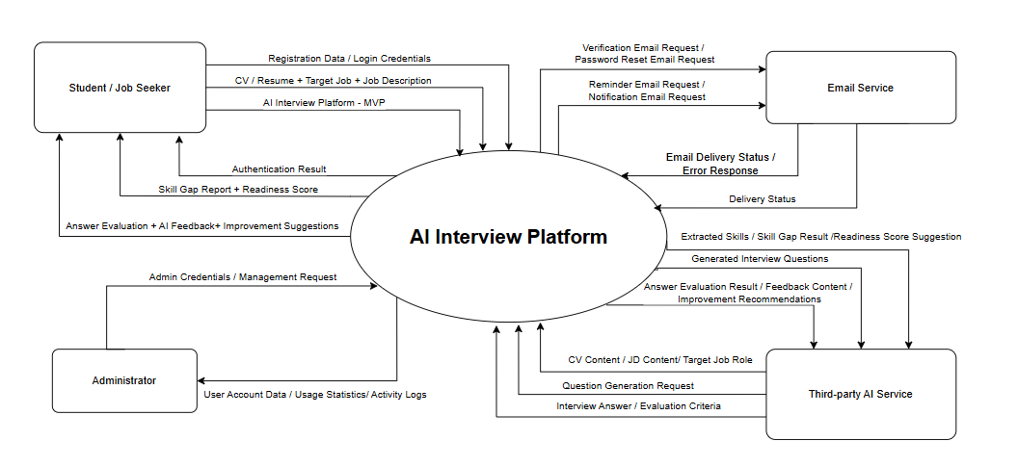

Product Functions
The AI Interview Platform shall provide a set of core functions that support users in preparing for job interviews through AI-powered analysis, practice, feedback, and progress tracking. This section summarizes the major functions of the product at a high level. Detailed functional requirements for each function will be described in the System Features section of this SRS.
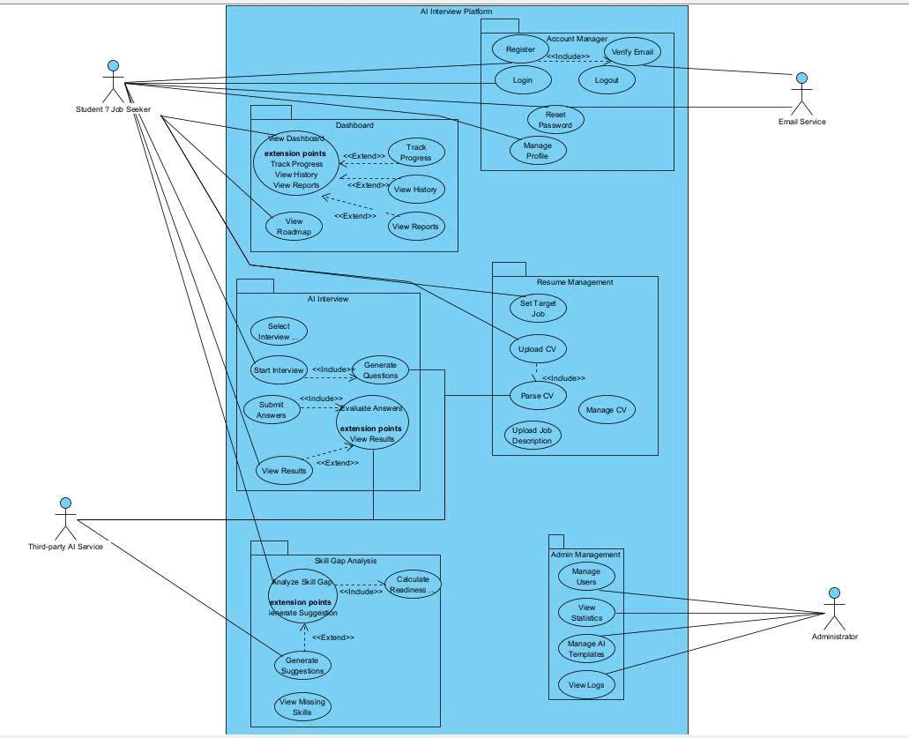
The major product functions are as follows:

2.2.1. User Account Management
The system shall allow users to create and manage their accounts. Users shall be able to register, log in, log out, reset passwords, and update basic profile information.
Main capabilities include:
- User registration using email and password.
- Secure login and logout.
- Password reset through email verification.
- User profile update.
- Role-based access for normal users and administrators.

2.2.2. Resume/CV Management
The system shall allow users to upload and manage their resumes or CVs. Uploaded resumes will be used as input data for skill gap analysis and personalized interview preparation.
Main capabilities include:
- Upload resume/CV files.
- Store resume/CV metadata.
- View uploaded resume information.
- Replace or update uploaded resumes.
- Use resume content for AI-based analysis.

2.2.3. Target Job Configuration
The system shall allow users to define their target job position and provide a job description. This information will be used to compare the user’s current profile against the expected requirements of the target role.
Main capabilities include:
- Define target job title or position.
- Input or upload job descriptions.
- Store target job information.
- Use job description data for personalized analysis.

2.2.4. Skill Gap Analysis
The system shall analyze the user’s resume/CV against the target job description to identify missing skills, strengths, weaknesses, and readiness level.
Main capabilities include:
- Analyze CV content and job description content.
- Identify matched skills.
- Identify missing or weak skills.
- Generate a readiness score.
- Display strengths and weaknesses to the user.

2.2.5. AI Mock Interview
The system shall allow users to practice mock interviews using AI-generated questions based on their target role and skill gap results.
Main capabilities include:
- Generate interview questions based on the target job.
- Support behavioral interview questions.
- Support technical interview questions.
- Allow users to answer questions in text format.
- Save interview session history.
- Evaluate user answers using AI scoring logic.

2.2.6. AI Feedback and Recommendation
The system shall provide AI-generated feedback after interview practice sessions. Feedback should help users understand what they did well, what needs improvement, and how they can improve their answers.
Main capabilities include:
- Evaluate answer clarity.
- Evaluate answer structure.
- Evaluate answer relevance.
- Identify weak communication patterns.
- Generate actionable improvement suggestions.
- Recommend improvement areas based on interview performance.
- Display detailed feedback after each interview session.

2.2.7. Personalized Learning Roadmap
The system shall generate a personalized interview preparation roadmap based on the user’s skill gaps, target job, and interview performance.
Main capabilities include:
- Generate customized preparation plans.
- Recommend learning activities based on weak skills.
- Define learning milestones.
- Allow users to track roadmap completion.
- Update recommendations based on user performance.

2.2.8. Dashboard and Progress Tracking
The system shall provide a dashboard that allows users to monitor their interview readiness, learning progress, skill improvement, and practice history.
Main capabilities include:
- Display readiness score over time.
- Show skill improvement trends.
- Display weak skill areas.
- Show completed and pending roadmap activities.
- Track interview practice history.
- Provide an overall progress dashboard.

2.2.9. Notification and Reminder
The system shall support basic notification and reminder functions to encourage users to continue their interview preparation activities.
Main capabilities include:
- Send reminders for incomplete learning roadmaps.
- Notify users when readiness scores improve.
- Support email-based notification delivery.

2.2.10. Admin Management
The system shall provide administrative functions for authorized administrators to manage users, monitor platform usage, and review system activity.
Main capabilities include:
Manage user accounts.
Monitor platform usage statistics.
Manage AI question templates where applicable.
View system activity logs.
Support administrative oversight of the platform.

User Classes and Characteristics

2.3.1. Overview
The AI Interview Platform - MVP is designed for two primary human user classes and two external system actors. Human user classes interact directly with the system interface, while external system actors provide supporting services required for AI processing and email communication.
The main user classes of the MVP are:
- Student / Job Seeker
- Administrator
- Third-party AI Service
- Email Service
Among these, Student / Job Seeker is the most important user class because this group represents the primary end users and directly drives the core business value of the platform. The BRD defines the platform as an AI-powered interview coaching system that helps users identify skill gaps, practice mock interviews, receive feedback, and track readiness over time.

2.3.2. User Class: Student / Job Seeker

Description
Student / Job Seeker is the primary user class of the system. This user uses the platform to prepare for job interviews through CV analysis, target job setup, mock interview practice, AI-generated feedback, personalized recommendations, and progress tracking.
This user class includes:
- University students preparing for internships or entry-level jobs.
- Fresh graduates preparing for their first full-time job.
- Job seekers who want to improve interview performance.
- Users who need structured interview preparation and measurable progress.

Characteristics
Characteristic | Description
Frequency of Use | Medium to high. Users may access the system several times per week during interview preparation periods.
Technical Expertise | Low to medium. Users are expected to have basic web browsing skills but may not have technical knowledge about AI systems.
Product Functions Used | Registration, login, CV upload, job target setup, mock interview, answer submission, feedback review, progress dashboard.
Security Level | Standard authenticated user. Can only access and manage their own data.
Educational Level | Mainly students, fresh graduates, and early-career job seekers.
Experience Level | May have limited real interview experience. The system should guide them clearly through the preparation process.
Priority | Highest. This is the most important user class for the MVP.

Main Goals
- Create and manage a personal account.
- Upload CV or resume.
- Define target job position.
- Input or upload job description.
- Identify missing skills.
- Practice interview questions.
- Receive AI feedback and improvement suggestions.
- Track interview readiness and learning progress.

Related Requirements
Requirement Area | Related Functions
User Authentication | Register, login, logout, password reset
Profile Management | Update profile, upload CV
Job Target Configuration | Define target job, input job description
Skill Gap Analysis | Analyze CV against JD, generate readiness score
AI Mock Interview | Generate questions, submit answers
AI Feedback | Evaluate answers, provide improvement suggestions
Progress Tracking | View readiness score, practice history, skill improvement

Importance
This user class has the highest priority because the success of the MVP depends on whether students and job seekers can effectively use the platform to improve interview readiness. Most core functional requirements in the BRD are designed around this user class, including CV upload, job target configuration, skill gap analysis, mock interview, AI feedback, personalized roadmap, and dashboard tracking.

2.3.3. User Class: Administrator

Description
Administrator is the internal operational user responsible for managing and monitoring the system. This user class does not participate in interview preparation but ensures that the platform operates correctly and that user activities can be monitored at a basic administrative level.

Characteristics
Characteristic | Description
Frequency of Use | Low to medium. Administrators may access the system periodically to monitor usage and manage data.
Technical Expertise | Medium. Administrators should understand basic system operations, user management, and monitoring functions.
Product Functions Used | Admin login, user management, usage statistics, question template management, activity log review.
Security Level | High privilege. Administrators can access administrative functions unavailable to normal users.
Educational Level | Project team member, system operator, or authorized staff.
Experience Level | Should understand basic platform operations and data privacy responsibilities.
Priority | Medium to high. Important for system control, but not the primary value driver of the MVP.

Main Goals
- Log in to the admin area.
- Manage user accounts.
- Monitor platform usage statistics.
- Manage AI question templates if included in MVP.
- Review system activity logs.
- Support troubleshooting and operational monitoring.

Related Requirements
Requirement Area | Related Functions
Admin Management | Manage users, monitor usage, manage question templates
Security | Restrict admin functions to authorized administrators
Logging | View system activity logs
Monitoring | Review usage statistics and platform activity

Importance
Administrator is a required user class for MVP operation because the system needs basic governance, user management, monitoring, and activity logging. However, this class is less important than Student / Job Seeker from a product value perspective.

2.3.4. External System Actor: Third-party AI Service

Description
Third-party AI Service is an external system actor that provides AI processing capabilities. The MVP depends on this actor to perform the core intelligent functions of the platform, including CV and job description analysis, skill gap identification, interview question generation, answer evaluation, feedback generation, and recommendation generation.
The BRD explicitly identifies dependency on external AI services and notes that AI feedback quality depends on third-party AI model capabilities.

Characteristics
Characteristic | Description
Type | External software service / API
Frequency of Use | High. The service is called whenever users request CV analysis, question generation, answer evaluation, or feedback.
Technical Expertise | Not applicable as a human user. Integration requires developer knowledge of API communication.
Product Functions Supported | Skill gap analysis, mock interview, answer evaluation, feedback generation, recommendation generation.
Security Level | System-to-system integration. Requires secure API communication and protection of user data.
Priority | High. This is a critical dependency for MVP functionality.

Main Responsibilities
- Analyze CV content.
- Analyze job description content.
- Extract skills from CV and JD.
- Identify skill gaps.
- Generate interview questions.
- Evaluate user interview answers.
- Generate feedback and improvement suggestions.
- Support readiness score calculation or recommendation logic.

Related Requirements
Requirement Area | Related Functions
Skill Gap Analysis | CV/JD analysis, skill gap identification
AI Mock Interview | AI-generated interview questions
AI Feedback | Answer evaluation, feedback generation
Recommendation Engine | Improvement suggestions, roadmap recommendations

Importance
Third-party AI Service is a high-priority external system because the MVP’s main differentiation depends on AI-generated analysis and feedback. If this service is unavailable or inaccurate, the core user experience will be directly affected.

2.3.5. External System Actor: Email Service

Description
Email Service is an external system actor responsible for sending system-generated emails. In the MVP, this service supports account-related and notification-related communication, such as password reset emails, verification emails, reminders, and basic notifications.
The BRD includes password reset via email verification and email-based notification delivery as part of the functional requirements.

Characteristics
Characteristic | Description
Type | External software service / email delivery provider
Frequency of Use | Medium. Used during registration, password reset, and notification events.
Technical Expertise | Not applicable as a human user. Integration requires email API or SMTP configuration.
Product Functions Supported | Account verification, password reset, reminders, notifications.
Security Level | System-to-system integration. Must protect email tokens and user contact information.
Priority | Medium. Important for account support and communication, but not the core AI function.

Main Responsibilities
- Send account verification emails.
- Send password reset emails.
- Send reminder emails.
- Send readiness score or progress notifications if enabled.
- Return email delivery status to the system.

Related Requirements
Requirement Area | Related Functions
Account Management | Password reset via email
Notification | Reminder and notification delivery
Security | Token-based verification and reset process

Importance
Email Service is important for account recovery and user communication. However, if MVP scope needs to be reduced further, some notification features may be deferred while keeping password reset as a core function.

2.3.6. User Class Priority Summary
User Class / Actor | Priority | Reason
Student / Job Seeker | Highest | Primary user and main source of product value
Third-party AI Service | High | Critical dependency for AI-based MVP features
Administrator | Medium to High | Required for system management and monitoring
Email Service | Medium | Required for password reset and communication support

Operating Environment
The AI Interview Platform - MVP will operate as a web-based application. Users access the system through modern web browsers. The system follows a client-server model, where the browser communicates with the backend server through HTTP/HTTPS. This is consistent with the web-based client-server architecture described in the Common Software Architecture document.

Component | Description
Client Device | Desktop, laptop, or tablet
Client Operating System | Windows, macOS, or other operating systems that support modern browsers
Browser | Chrome, Microsoft Edge, Firefox
Server Environment | Web application server with backend API
Database | Stores user accounts, CV metadata, job targets, interview sessions, feedback, and progress data
File Storage | Stores uploaded CV/resume files
External Services | Third-party AI Service and Email Service
Communication Protocol | HTTPS
API Style | RESTful API using JSON

Design and Implementation Constraints
The following constraints limit the design and implementation options of the MVP:

Constraint | Description
MVP Scope Limitation | The system focuses only on core interview preparation features.
Academic Timeline | The project must be completed within the academic project schedule.
Limited Development Resources | The system is developed by a student team with limited time and technical resources.
Text-based Interview Only | The MVP supports text-based interview answers only. Voice interview is excluded from the initial release.
No Multi-language Support | Multi-language interview support is not included in the MVP.
Third-party AI Dependency | AI feedback quality, response time, and availability depend on the selected AI service.
Email Service Dependency | Password reset and notifications depend on the external email service.
Web-based Architecture | The system must be implemented as a browser-based web application.
Security Requirement | The system must use authentication, protect user data, restrict admin functions, and communicate through HTTPS.
Data Privacy | Uploaded CVs, interview answers, and feedback data must be protected from unauthorized access.
Maintainability | The system should use modular design to support future feature expansion and AI model upgrades.

User Documentation\
The following documentation will be delivered with the MVP:

Document | Target User | Description | Format
Getting Started Guide | Student / Job Seeker | Explains how to register, log in, and start using the system. | Online help / PDF
CV and Job Setup Guide | Student / Job Seeker | Explains how to upload CV and enter target job information. | Online help
Mock Interview Guide | Student / Job Seeker | Explains how to start a mock interview and submit answers. | Online help
AI Feedback Guide | Student / Job Seeker | Explains how to understand readiness score, feedback, and improvement suggestions. | Online help
Progress Dashboard Guide | Student / Job Seeker | Explains how to view progress, practice history, and skill improvement. | Online help
Admin Guide | Administrator | Explains user management, usage monitoring, and activity log review. | PDF / Internal document
Deployment Guide | Development Team | Explains how to deploy and configure the system. | Technical document

Assumptions and Dependencies
Assumptions

ID | Assumption
ASM-001 | Users are willing to use AI-generated feedback for interview preparation.
ASM-002 | Users can provide a CV and target job description for analysis.
ASM-003 | Users have stable internet access to use the web application.
ASM-004 | The selected AI service can provide sufficiently accurate interview analysis and feedback.
ASM-005 | The selected technology stack can support MVP development and operation.
ASM-006 | The development team has enough technical capability to implement the core MVP features.
ASM-007 | Testing participants will be available during the academic project timeline.
ASM-008 | The MVP will focus on text-based interview practice and will not require voice interview processing.
Dependencies

ID | Dependency | Description
DEP-001 | Third-party AI Service | Required for CV/JD analysis, skill gap detection, question generation, answer evaluation, feedback, and recommendations.
DEP-002 | Email Service | Required for password reset, email verification, reminders, and notifications.
DEP-003 | Hosting Environment | Required to deploy and run the web application.
DEP-004 | Database | Required to store user accounts, job targets, interview sessions, feedback, and progress data.
DEP-005 | File Storage | Required to store uploaded CV/resume files.
DEP-006 | Internet Connection | Required for users to access the system and for the system to call external services.
DEP-007 | Modern Web Browsers | Required for users to access the system interface.
DEP-008 | API Keys and Credentials | Required for secure integration with AI and email services.

External Interface Requirements

User Interfaces
<Describe the logical characteristics of each interface between the software product and the users. This may include sample screen images, any GUI standards or product family style guides that are to be followed, screen layout constraints, standard buttons and functions (e.g., help) that will appear on every screen, keyboard shortcuts, error message display standards, and so on. Define the software components for which a user interface is needed. Details of the user interface design should be documented in a separate user interface specification.>

Hardware Interfaces
<Describe the logical and physical characteristics of each interface between the software product and the hardware components of the system. This may include the supported device types, the nature of the data and control interactions between the software and the hardware, and communication protocols to be used.>

Software Interfaces
<Describe the connections between this product and other specific software components (name and version), including databases, operating systems, tools, libraries, and integrated commercial components. Identify the data items or messages coming into the system and going out and describe the purpose of each. Describe the services needed and the nature of communications. Refer to documents that describe detailed application programming interface protocols. Identify data that will be shared across software components. If the data sharing mechanism must be implemented in a specific way (for example, use of a global data area in a multitasking operating system), specify this as an implementation constraint.>

Communications Interfaces
<Describe the requirements associated with any communications functions required by this product, including e-mail, web browser, network server communications protocols, electronic forms, and so on. Define any pertinent message formatting. Identify any communication standards that will be used, such as FTP or HTTP. Specify any communication security or encryption issues, data transfer rates, and synchronization mechanisms.>

System Features
<This template illustrates organizing the functional requirements for the product by system features, the major services provided by the product. You may prefer to organize this section by use case, mode of operation, user class, object class, functional hierarchy, or combinations of these, whatever makes the most logical sense for your product.>

System Feature 1
<Don’t really say “System Feature 1.” State the feature name in just a few words.>
4.1.1 Description and Priority
<Provide a short description of the feature and indicate whether it is of High, Medium, or Low priority. You could also include specific priority component ratings, such as benefit, penalty, cost, and risk (each rated on a relative scale from a low of 1 to a high of 9).>
4.1.2 Stimulus/Response Sequences
<List the sequences of user actions and system responses that stimulate the behavior defined for this feature. These will correspond to the dialog elements associated with use cases.>
4.1.3 Functional Requirements
<Itemize the detailed functional requirements associated with this feature. These are the software capabilities that must be present in order for the user to carry out the services provided by the feature, or to execute the use case. Include how the product should respond to anticipated error conditions or invalid inputs. Requirements should be concise, complete, unambiguous, verifiable, and necessary. Use “TBD” as a placeholder to indicate when necessary information is not yet available.>

<Each requirement should be uniquely identified with a sequence number or a meaningful tag of some kind.>

REQ-1:
REQ-2:

System Feature 2 (and so on)

Other Nonfunctional Requirements

Performance Requirements
<If there are performance requirements for the product under various circumstances, state them here and explain their rationale, to help the developers understand the intent and make suitable design choices. Specify the timing relationships for real time systems. Make such requirements as specific as possible. You may need to state performance requirements for individual functional requirements or features.>

Safety Requirements
<Specify those requirements that are concerned with possible loss, damage, or harm that could result from the use of the product. Define any safeguards or actions that must be taken, as well as actions that must be prevented. Refer to any external policies or regulations that state safety issues that affect the product’s design or use. Define any safety certifications that must be satisfied.>

Security Requirements
<Specify any requirements regarding security or privacy issues surrounding use of the product or protection of the data used or created by the product. Define any user identity authentication requirements. Refer to any external policies or regulations containing security issues that affect the product. Define any security or privacy certifications that must be satisfied.>

Software Quality Attributes
<Specify any additional quality characteristics for the product that will be important to either the customers or the developers. Some to consider are: adaptability, availability, correctness, flexibility, interoperability, maintainability, portability, reliability, reusability, robustness, testability, and usability. Write these to be specific, quantitative, and verifiable when possible. At the least, clarify the relative preferences for various attributes, such as ease of use over ease of learning.>

Business Rules
<List any operating principles about the product, such as which individuals or roles can perform which functions under specific circumstances. These are not functional requirements in themselves, but they may imply certain functional requirements to enforce the rules.>

Other Requirements
<Define any other requirements not covered elsewhere in the SRS. This might include database requirements, internationalization requirements, legal requirements, reuse objectives for the project, and so on. Add any new sections that are pertinent to the project.>
Appendix A: Glossary
<Define all the terms necessary to properly interpret the SRS, including acronyms and abbreviations. You may wish to build a separate glossary that spans multiple projects or the entire organization, and just include terms specific to a single project in each SRS.>
Appendix B: Analysis Models
<Optionally, include any pertinent analysis models, such as data flow diagrams, class diagrams, state-transition diagrams, or entity-relationship diagrams.>
Appendix C: To Be Determined List
<Collect a numbered list of the TBD (to be determined) references that remain in the SRS so they can be tracked to closure.>

